Inventory App Development Proposal

Project 1

CS 360 Mobile Architect and Programming

Nicholle Caudy

5/21/2025

The purpose of the Inventory app is to adjust and maintain proper inventory counts to keep the business updated. The app will have a database with a table to store inventory items and a table to store the user logins and passwords. There will be a mechanism for the user to add or remove items from the inventory list. The app will have buttons to increase (+) or decrease (-) the inventory amount by one and a text field to enter the exact amount in inventory for a specific item. There will also be a mechanism that will track when an item’s inventory count reaches zero, this will allow the user to know when it is time to reorder an item. The inventory app will have a screen with a grid to display all the items that are in the inventory. The app will have a screen that requires the users to log in before using the app. This screen will have text fields to type in user information, a log in button, and a hyperlink if the user needs to create a login and password. If the user has never used the app before they will have the ability to create a login and password if they are part of the company’s database. Requiring a login for the inventory app will ensure security by preventing unauthorized inventory adjustments and enabling the tracking of changes made and identifying the individuals who made them.

Anyone wanting to track the quantity of items can use the app. This can include companies with a large inventory base, small businesses, restaurants, office managers, doctor’s offices, hospitals, or well-organized families. Businesses of all sizes can utilize the app to monitor their inventory levels, both incoming and outgoing, to ensure orders are fulfilled and products are available for customers. The app provides notifications when specific items are out of stock, allowing businesses to manage their inventory efficiently. Restaurants can use the app to track items such as napkins, straws, kids color mats, crayons, food items, cleaning supplies, and restroom supplies. The goal a doctor’s office of hospital might hope to achieve while using this app tracking the inventory levels of medical supplies, cleaning supplies, and restroom supplies. Office managers can track office supplies and know when to order an item when it is low. A family might have a goal to keep better track of their household supplies to make grocery shopping more efficient and to remind them to get a rarely used item when it reaches zero. The users will need a screen to see the items they have added to the database and the quantity of each item, with the ability to adjust those quantities and add or remove items from their database. Users will have secure login to prevent unauthorized inventory adjustments.

The user's inventory objectives will be achieved through an application designed with a user-centered interface (UI). Following the guidelines provided by the Android Design and Quality Guidelines, the app will follow similar app layouts to make transitioning to this app simpler and intuitive. Using a FAB to save changes without having to scroll to the bottom of the inventory list will make for faster updates and increase usability. Making the layout easy to read and navigate. The first screen the users will encounter upon opening the app is a login screen. This screen will include text fields to enter the username, password, hyperlink for new users, and login button. When new users start the app, they will press the hyperlink to create a username and password (adding them to the database for users) for that app if the login and password information are entered correctly, they will be redirected to the login screen to login. After entering the username and password the user will press the log in button that will authenticate their user information against the database table that stores the usernames and passwords.

After logging in, the user will be directed to a screen that shows their profile, the current date, and a grid view of all items in the inventory database. Across the top of the screen there will be a series of buttons “HELP,” “LOGOUT,” “ADD ITEM,” “UPDATE ITEM,” and “REMOVE ITEM.” Within the grid view the user will be able to increment or decrement the quantity of items within the list or use the text field to enter a quantity manually. There will be a floating action button (FAB) labeled “SAVE” to save any adjustments made updating the inventory database.

Pressing the “ADD ITEM” button will open another screen where the user can add the new item’s description (will accept letters or integers), item or stock numbers (integers only), and quantities (integers only) up to five items at a time. After entering the information, users will press the "ADD ITEM" button to save the data to the inventory database.

The “UPDATE ITEM” button will allow the user to update the information of an already existing item to change item description, item/stock number, or quantity. The user with highlight (press) an individual item then presses the “UPDATE ITEM” button to open a pop-up to change the information. Once modifications are completed, the “UPDATE” button will be pressed to refresh the inventory database and present the updated information in the grid view display.

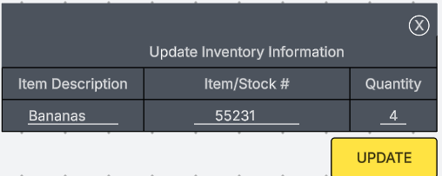

To remove an item from inventory they user will simply highlight (press) the desired item and press the “REMOVE ITEM” button. They will encounter a pop-up warning message stating “Delete item (selected item)” with buttons to confirm or cancel. Confirming will remove the item from the inventory database and update the grid view. If the user presses cancel, nothing will change.

Press the "HELP" button to open a menu that explains the app's buttons and their uses.

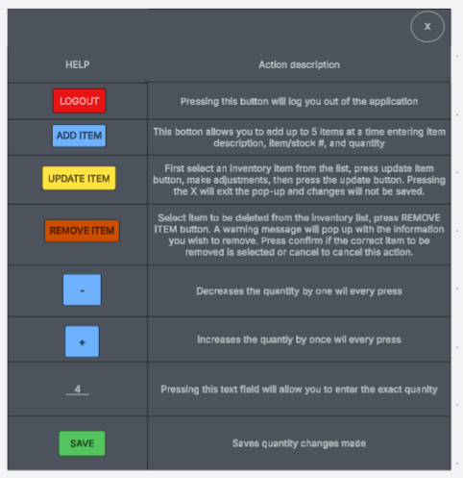

The “LOGOUT” button when pressed with pop-up a warning stating “Are you sure you want to Logout?” with action buttons “YES” or “NO.” Pressing “YES” will log the user out of the application and pressing “NO” will return the user back to the main screen.

The functional app requirements will include the following, starting with the login screen. The login screen will include two text fields. One text field will be for the user’s username (will have hint text to notify the user), the other text field will be for the user’s password (will have hint text to notify the user). The username will need to be at least six characters long, and the password will need to be at least eight characters long and must include at least one upper case letter, at least one number, and at least one special character. A hyperlink will be present for new users to create login information. After entering user credentials, click the "Login" button. After the user presses login, the system will call the username/password database to authenticate the user’s entered information. Incorrect credentials will redirect the user to the login screen. If the credentials are correct, the user will access the inventory details screen.

This screen will start with calls to the inventory database and loading the information in a grid view for the user. This inventory details screen includes several buttons that enable users to access various features within the application. The “HELP” button will display a help menu with helpful tips and details on how the app works and how to navigate the functions. The “ADD ITEM” button will open a screen that will allow the user to add up to five items at a time with item descriptions (will accept letters and integers), item/stock numbers (will accept integers only), and quantity (will accept integers only). After the user enters the information, they will press the “ADD ITEMS” button at the bottom of the screen. Upon pressing this button, the inventory database will be accessed to add the new items, and the inventory details screen will reflect these updates.

The user can select an item from the listed inventory and press “UPDATE ITEM” this will open a pop-up window that will allow them to change the item’s description (will accept letters and integers), number (will accept integers only), and quantity (will accept integers only). Following the changes, the user will press the “UPDATE” button. This action will call the inventory database again and apply the modifications to the specified item, updating the inventory details screen accordingly.

If the user wants to remove/delete and item from the inventory they will select the item and press the “REMOVE ITEM” button, this will open a warning pop-up asking the user to confirm the removal/deletions of the selected item. The user can press “CANCEL” to cancel the process or “CONFIRM” to save the changes. When the user presses “CONFIRM,” a call is made to the inventory database to remove the item, and the changes are reflected on the inventory details screen.

Within the grid view on the inventory details screen there are two buttons and a text field for each item on the inventory list. The user will find the item on the inventory list they wish to check/adjust, the user can then use the subtract button to decrease the quantity by one, the addition button to increase the quantity by one, or the text field (accepts only integers) to manually enter the current amount. Once changes are made the user will press the FAB (floating action button) labeled “SAVE” to save the changes made. Pressing the “SAVE” button will again call the inventory database to update the quantity and update the inventory details screen.

If the user has finished their work, needs to take a break, or must step away from their device for any reason they will need to press the “LOGOUT” button. After the logout button has been pressed the user will get a warning pop up asking them “Are you sure you want to logout?”, the user can then press “NO” to cancel the logout request, or “YES” to confirm the action and the system will log the user out, stop and return to the login screen.

References

[Layout basics  |  Mobile  |  Android Developers](https://developer.android.com/design/ui/mobile/guides/layout-and-content/layout-basics)